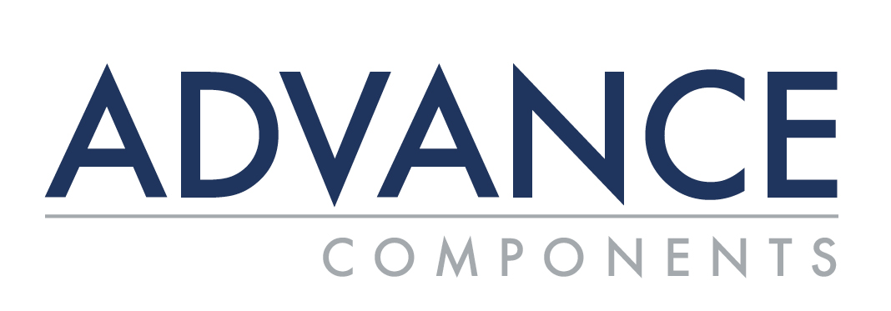

Customized Solutions

Advance Components, based in Carrollton (Dallas), TX, has been the industry’s leading supplier of high quality specialty fastener products for over 45 years. Advance stocks products from best-in-class suppliers like ARaymond Tinnerman, AVK, Davies Molding, Heyco, Johnson & Hoffman, Micro Plastics/Essentra, and Vogelsang Fastener Solutions.

At Advance, our focus is on providing strategic opportunities for reducing price volatility and improving cash flow to customers. We work with customers to create a flexible program that molds to customers’ needs, including lock up pricing, providing dedicated inventory, “1PO” (flexible scheduled releases), supplier management, consolidation of suppliers, and shipment consolidation. We create programs that are made to suit customers’ unique business processes. We are committed to meeting all of our customers’ specific needs in order to help them gain total control over their inventory.

Advance also offers Fulfillment Services including kitting, bagging, storage, handling, pick/pack, shipping, returns and special project work.

Our dedication to long-term relationships is a company-wide commitment to how we bring value to customers every day. For more than 45 years, we have been building strong connections with our customers - connections founded on trust and mutual success.

Find how Advance’s flexible inventory management program can mold to fit your business.

Contact:
Web: advancecomponents.com
VP Account Management/Inside Sales: Terri House, terrih@advancecomponents.com
National Sales Manager/Outside Sales: Brad Burel, bradb@advancecomponents.com

